Microsoft Teams Student Log-in Guide

Teaching, Learning, and Technology

August 2020
Welcome to Microsoft Teams! This platform will be used by your instructors for video conferences in your virtual classroom space. Live class sessions, office hours, and other important resources will be utilized in Teams to create community in your courses and to enhance your learning. Please be sure to follow the steps below to log in and be on the lookout for upcoming student training on using Microsoft Teams. Our college has partnered with Microsoft Education to provide the training for you. These sessions will be scheduled throughout the semester to provide student support. Please attend these sessions to learn how to maximize your use of Teams, and to ask questions of the educational technology experts at Microsoft.
- Please accept the email invitation to join Microsoft Teams. If you have already logged in to Teams, then this email will simply bring you back to your most recent activity in the application.
- When first logging in, please uncheck the manage my device option when prompted, and then review and accept the permissions for your device.
- Then, download the Microsoft Teams desktop/mobile application using the following link: Download Teams, and sign in with your college username and password. Note: Please make sure you are signing in with your college account and not a personal email. After your initial login, use the desktop version whenever possible. You can access the web version from the following link as well: Teams Web Version.
- When in the Teams application, you will have two accounts. Please choose the account in the following format: College (Guest). This is to ensure privacy for both instructor and students alike, so please select this account to access your Teams (i.e., your classes). In the application, this can be toggled easily be viewing the drop-down menu in the upper right-hand corner of the Teams application to the left of your profile initials. Select College (Guest) from the two options you have. See screenshots below:
  - In this image, you can see the number 1 in a red circle over the down arrow. That shows that there’s a team available under a different context. Note: You will see a team code prompt, and you will see this if you are not on the right user account. Follow the directions below on how to access the correct account:
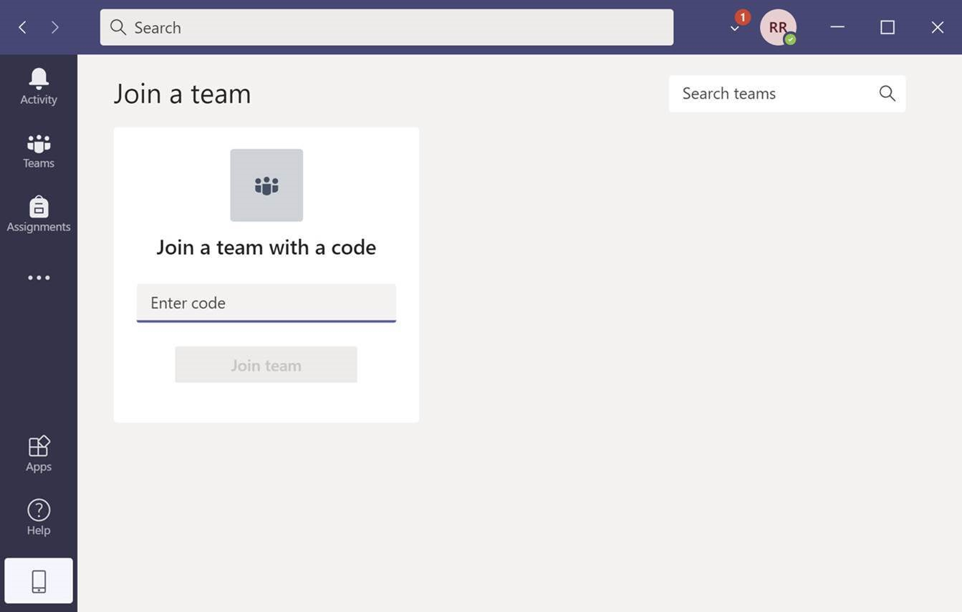
- If you look closer below, you should see the drop-down menu with the option to toggle between College and College (Guest). Choose the College (Guest) option.

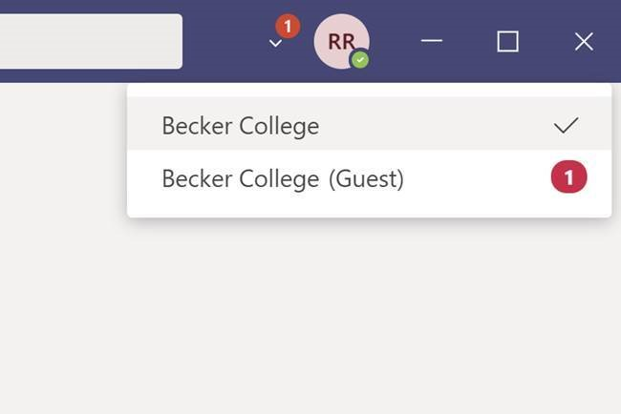

- Once you have changed user account to the format College (Guest), your teams will appear by locating the Teams icon to the left on the navigation bar. Here, you will find all of your class teams.
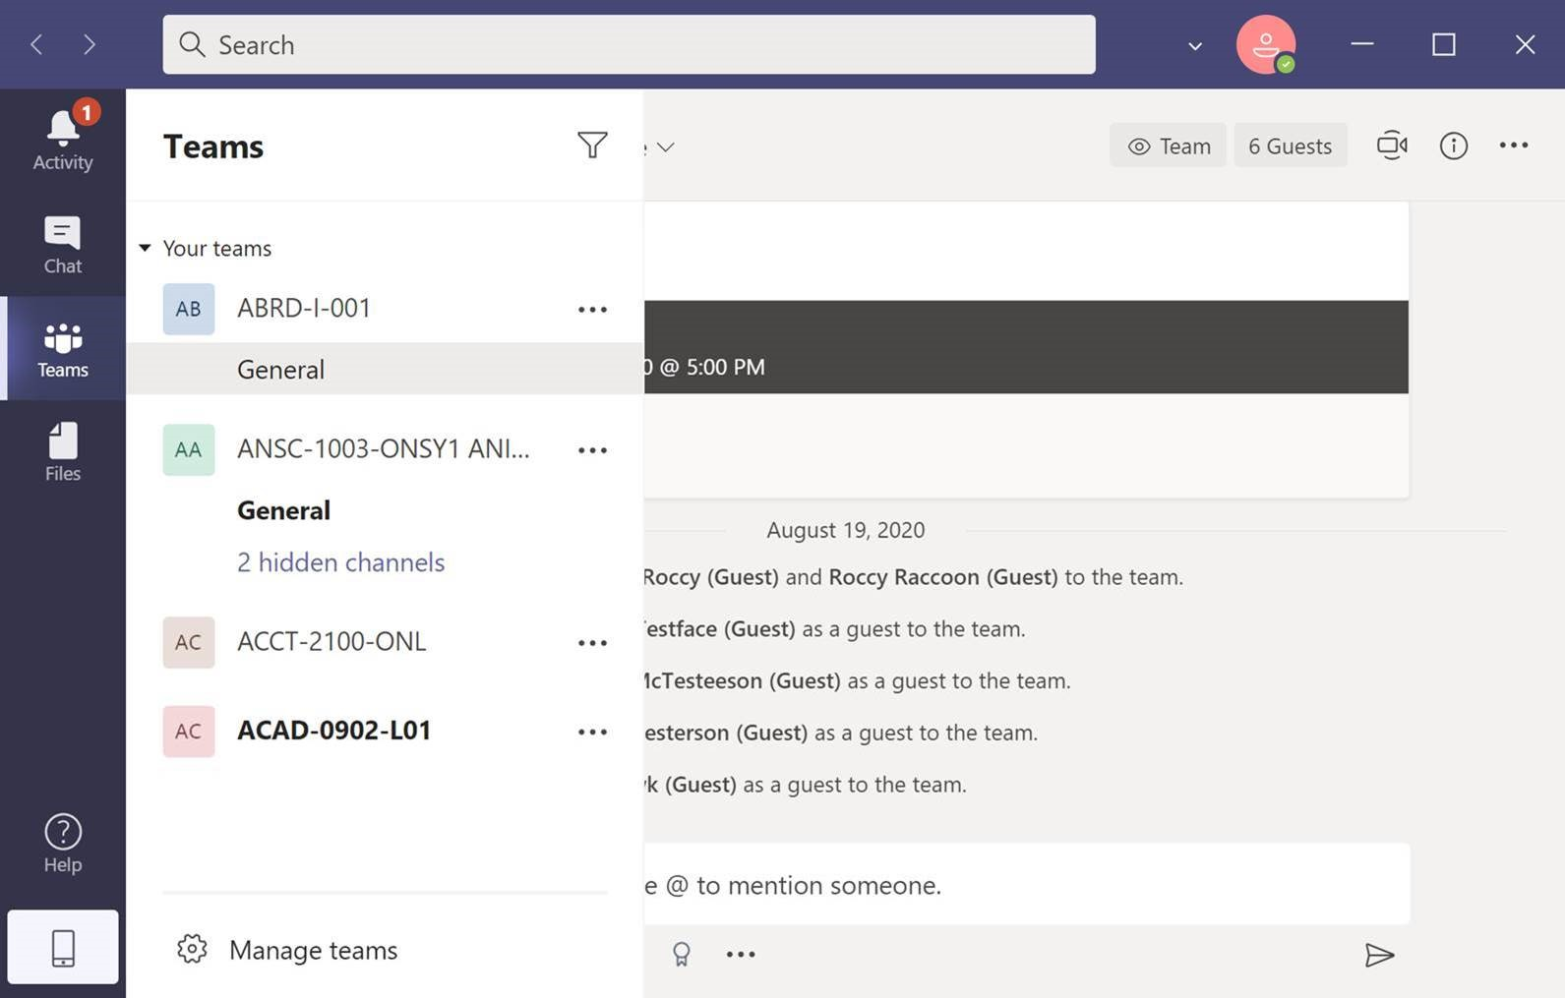
5. Locate your Teams on the left side navigation bar with the icon that has three virtual people and begin accessing the virtual conferencing platform. Note: The College (Guest) account does not have immediate access to the calendar in Teams for privacy reasons as your individual calendars are just that, private. You can still access these calendars through your own Outlook, as they are synced.
6. Attend the training sessions presented by Microsoft Education and the TLT throughout the semester, starting the first week of classes on Tuesday August 25th, 2020. Note: Instructors will be using Teams in different ways, so be sure to see how they will be utilizing the platform.

